Plants and Microscope Jeopardy Questions
Photosynthesis and Cellular Respiration:
100 points
Question: Why do plants need to do both photosynthesis and cellular respiration?
Answer:

200 points
Question: How are the materials and products of photosynthesis and cellular respiration related?
Answer:

300 points
Question: Where is chlorophyll found in a plant cell? What is chlorophyll’s function?
Answer:

400 points
Question: Photosynthesis is the process that allows plants to make their own food, therefore they are called __________________?
Answer:

500 points
Question: Explain two reasons why plants being able to undergo photosynthesis help us.
Answer:

Mixed Bag:
100 points
Question: If the eyepiece of the microscope is 10x and the medium power objective is 10x, what is the total magnification?
Answer:

200 points
Question: True/False. If false-write a sentence or two explaining why. You should always use the coarse objective knob when focusing on high power.
Answer:

300 points
Question: Explain the difference between pollination and fertilization.
Answer:

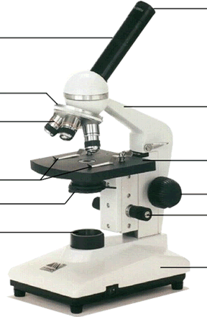

A
400 points
Question: What is letter A pointing to? What is its job? What is letter B pointing to? What is its job?
B
Answer:

500 points
Question: Explain 3 ways seeds can be dispersed.
Answer:

Flower/Plant Reproduction:
100 points
Question: What is the function of the anther and why is it so important in plant reproduction?
Answer:

200 points
Question: After the eggs are fertilized by pollen the ovary swells and becomes a ___________.
Answer:

300 points
Question: What is the letter D pointing to? What are its TWO functions?
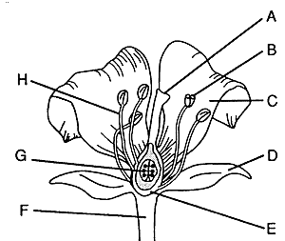

Answer:

400 points
Question: What two letters make up the male part of the flower? What are the parts called and what are their functions? What is the entire male part named?

Answer:

500 points
Question: What is the female part of the flower called? What three parts make up the female part? What is all three of their functions?
Answer:

Atoms, Molecules and Compounds:
100 points
Question: What is an atom?
Answer:

200 points
Question: What is an element? Give three examples.
Answer:

300 points
Question: What does the 12 mean in C₆H₁₂O₆?
In the below equation, how many molecules of C₆H₁₂O₆ are there?
6CO₂ + 6H₂O àC₆H₁₂O₆ + 6O₂
Answer:

400 points
Question: Is a molecule always a compound? Explain.
Answer:

500 points
Question: What are the equations for photosynthesis and cellular respiration?
Answer:

Plant Basics:
100 points
Question: Name the outer surface of a plant’s skin.
Answer:

200 points
Question: Explain why plants want their seeds to be spread out.
Answer:

300 points
Question: How does CO₂ enter the plant? Where are these found?
Answer:

400 points
Question: It requires a lot of energy for a plant to produce a fruit. Explain why a plant would spend this large amount of energy.
Answer:

500 points
Question: What does the word “Eukaryotic” mean and how does it relate to plants?
Answer:

