Name-______________________________________
Date-_________________

1) In solution, linear D-glucose forms a ring by reaction of the hydroxyl oxygen on the carbon 5 with the carbon of aldehyde at position 1 (Figure 1A). Depending on which side carbon 1 is attacked, the resulting hydroxyl group can be located either above the ring (β-glucose) or below the ring (α-glucose). The α-glucose form is represented in Figure 1A. Shown along with the Fischer projection of linear D-glucose and the Haworth projection of circular α-D-glucose, are two more realistic representations of the energetically favorable chair conformation of α-D-glucose.

Polysaccharides are formed by linkage of sugar monomers via glycosidic bonds. Amylose and cellulose, for example, are polysaccharides composed entirely of hexoses (six-carbon sugars) that are linked together by glycosidic bonds between the number 1 and 4 carbons of adjacent monomers. Structures of amylase and cellulose with the hexoses in the chair conformation are shown in Figure 1B and Figure 1C. Which, if either, of these polysaccharides is composed entirely of α-D-glucose? What are the similarities and differences between the structures of amylase and cellulose? Explain your reasoning.

Figure 1:
A) D-glucose
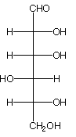 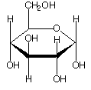 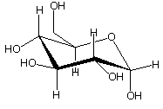 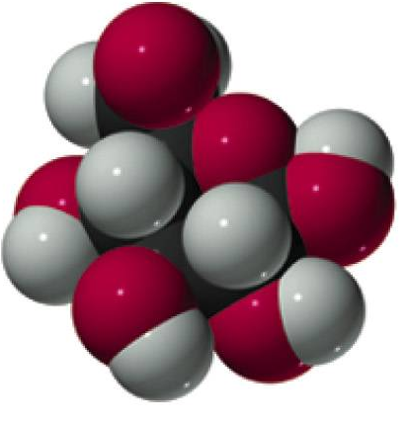 Fischer projection Haworth projection chair conformation space filling model

B) Amylose

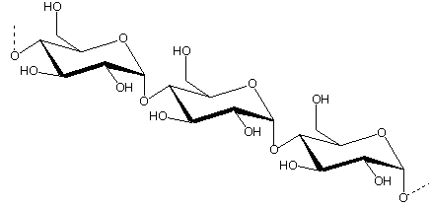
C) Cellulose
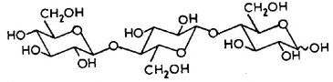
2) What does the term ‘amphipathic mean? Figure 2 shows a fatty acid, a triacyglycerol, and a phospholipid. Indicate which of these molecules are amphipathic and illustrate/explain the reason why. How do their amphipathic characteristics account for the typical structures these molecules form in cells?

Figure 2:
a) Fatty Acid b) Triacylglycerol
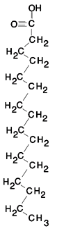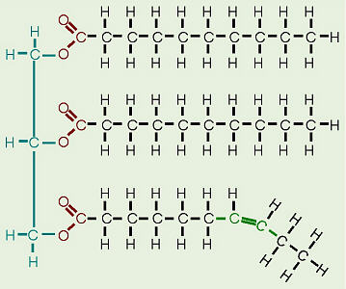

c) Phospholipid
