Name-___________________________
Date-__________________

1) Bacterial plasmids range in size from 1,000 to 200,000 bp, and are used extensively for cloning purposes. The plasmid drawn below has cutting sites for the following restriction enzymes: EcoR1, Sal1, and BamH1. The distance in base pairs (bp) between cutting sites is listed between the sites. Answer the following questions based on your knowledge of biology and the diagrams below labeled (a) through (e).
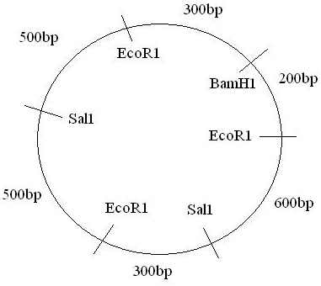
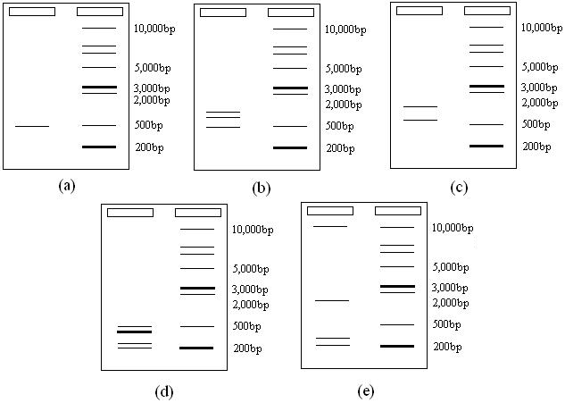
- Which of the gel electrophoresis results would you expect after cutting the cloning plasmid with the restriction enzyme EcoR1? Why?

- Which of the gel electrophoresis results pictured above would you expect after cutting the cloning plasmid with the restriction enzyme Sal1? Why?

- Which of the gel electrophoresis results pictured above would you expect after cutting the cloning plasmid with all three restriction enzymes-EcoR1, Sal1, and Bam1-all at the same time? Why?

2) A linear piece of DNA is cleaved with the individual restriction enzymes HindIII and SmaI and then with a combination of the two enzymes. The fragments obtained are:

HindIII 2.5 kb, 5.0 kb
SmaI 2.0 kb, 5.5 kb
HindIII and SmaI 2.5 kb, 3.0 kb, 2.0 kb

- Draw the restriction map

- The mixture of fragments produced by the combined enzymes is cleaved with the enzyme EcoRI, resulting in the loss of the 3-kb stained band (on an electrophoresis gel) and the appearance of a 1.5-kb stained band. Mark the EcoRI site cleavage site on the restriction map.

3) Duchenne muscular dystrophy is an X-linked recessive disease. Victims of the disease become progressively weaker, starting early in life.
- What is the probability that a woman whose brother has the disease will have an affected child?

- If your mother’s brother (aka your uncle) had Duchenne muscular dystrophy, what is the probability that you have received the allele?

- If your father’s brother had the disease, what is the probability that you have received the allele?

4) The accompanying pedigree concerns a certain rare disease that is incapacitating but not fatal.
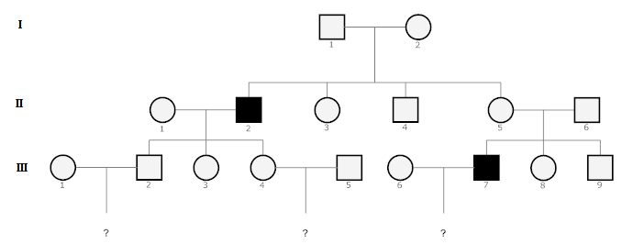
- Determine the mode of inheritance of this disease (i.e. autosomal dominant, autosomal recessive, sex linked).

- Write the genotype of each individual according to your proposed mode of inheritance (assume that person II-1, III-1, and III-6 have no history of this disease).

- If you were this family’s doctor, how would you advise the three couples in the third generation about the likelihood of having an affected child?

