Name-____________________
PS #3
1) One strand of a section of DNA isolated from E. coli reads 5’-GTAGCCTACCCATAGG-3’
A) Suppose that an mRNA is transcribed from this DNA using the complementary strand as a template. What will the sequence of the mRNA in this region be?
B) How many different peptides could potentially be made from this sequence of RNA? Would the same peptides be made if the other strand of the DNA served as the template for transcription?
C) What peptide would be made if translation started exactly at the 5’ end of the mRNA in part A? When tRNA^{Ala} leaves the ribosome, what tRNA will be bound next? When the amino group of alanine forms a peptide bond, what bonds, if any, are broken, and what happens to tRNA^{Ala}?
D) Suppose this stretch of DNA is transcribed as indicated in part A, but you do not know which reading frame is used. Could this DNA segment originate from the beginning of the coding region of a gene? The middle? The end? How can you tell?

2) Rates of peptide chain growth can be estimated from data such as those shown in Figure 1. In this experiment, a single TMV (tobacco mosaic virus) mRNA species encoding a 116,000-dalton protein was translated in a rabbit–reticulocyte lysate in the presence of ³⁵S-methionine. Samples were removed at 1-minute intervals and subjected to electrophoresis on SDS-polyacrylamide gel. The separated translation products were visualized by autoradiography. As is apparent in Figure-1, the largest detectable proteins get larger with time.
A) Describe the purpose of ³⁵S-methionine.
B) What is polyacrylamide gel electrophoresis? What does it do?
C) Is the rate of synthesis linear with time? *Hint* A simple way to answer this question is to determine the molecular mass of the largest peptide in the sample, as determined by reference to the standards shown on the left in Figure 1, and then plot each of these masses against the time at which the relevant sample was taken.
D) What is the rate of protein synthesis (in amino acids/minute) in the experiment? Assume the average molecular mass of an amino acid is 110 daltons.
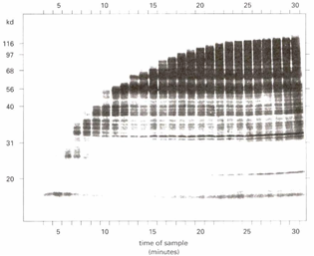
Figure 1

